We'll configure our application to talk to the database deployed in AWS. And also we'll deploy this Spring Boot application to AWS using AWS Elastic Beanstalk. But we'll get into all that later. So, now we'll simply focus on running the application locally.

We'll have two database scripts and they'll be in this folder called SQL scripts. We'll have two files. We'll have this one file **01-create-user.sql** and another **02-employee-directory.sql**. I'll give you the details on how to download these SQL files in the next section.

**01-create-user.sql** : It will have the user id of ***springstudent*** and also the password of ***springstudent***.

**02-employee-directory.sql :** It basically creates a new database table called employee and also loads this table with sample data.

**Set up CRUD application locally**: in the resources section of this video, there's a zip file that you can download spring-boot-3-spring-mvc-crud.zip, open in Intellij ide

as a quick overview, as far as the big picture of the application architecture,   
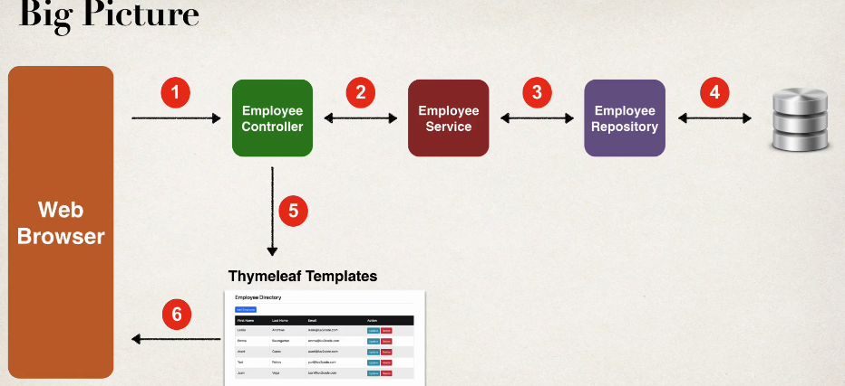  
we'll have our web browser come in. It'll make calls to the controller, pass it over to the service to the repository, the repo hits the database, gets the data back, and then it'll send it over to our time leaf templates or our view pages. And I'll actually go back to the browser. So that's kind of the basic layout of this application. This is kind of like a standard architecture that you'll see for Spring Boot spring MVC, Crud applications.